**LAB#14**

**Open Ended Lab**

**OBJECTIVE:**

The objectives for the tasks involve implementation of searching techniques such as Breath first search ,depth first search and implement different task using concept of class and dictionary.

**LAB TASK:**

**Task01:**

Apply Breadth First Search on following graph considering the initial state is A and final state is F. Show results in form of open and closed list.

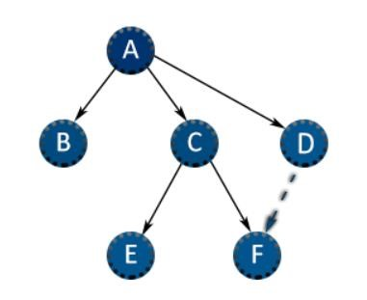 **CODE:**

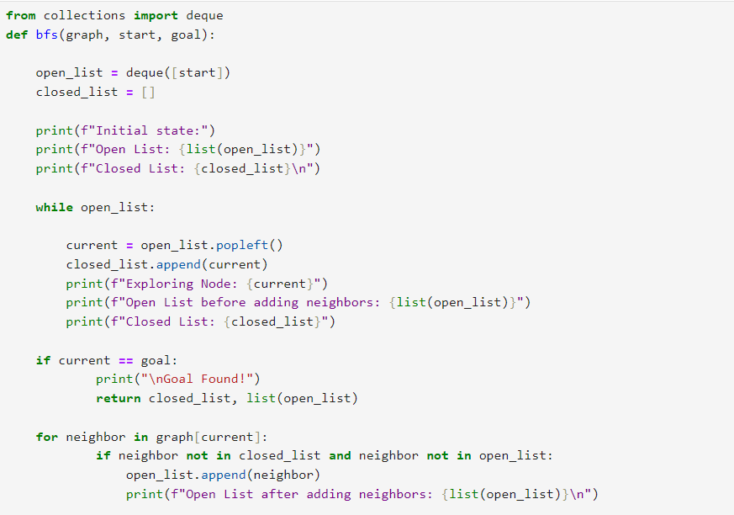

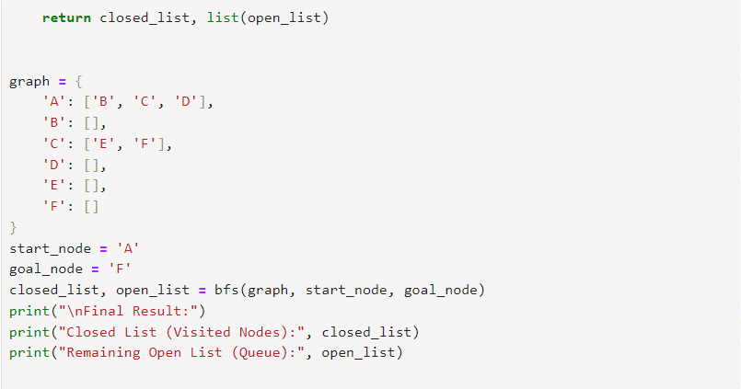

**Output:**

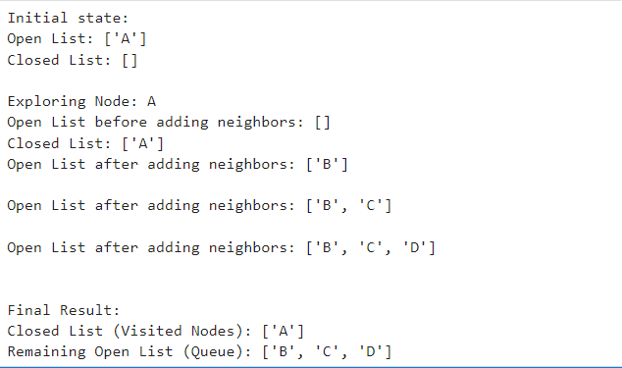

**Task02:**

Apply Depth First Search on the graph given in question 1. Considering the initial state is A and final state is F. Show results in form of open and closed list.

**CODE:**

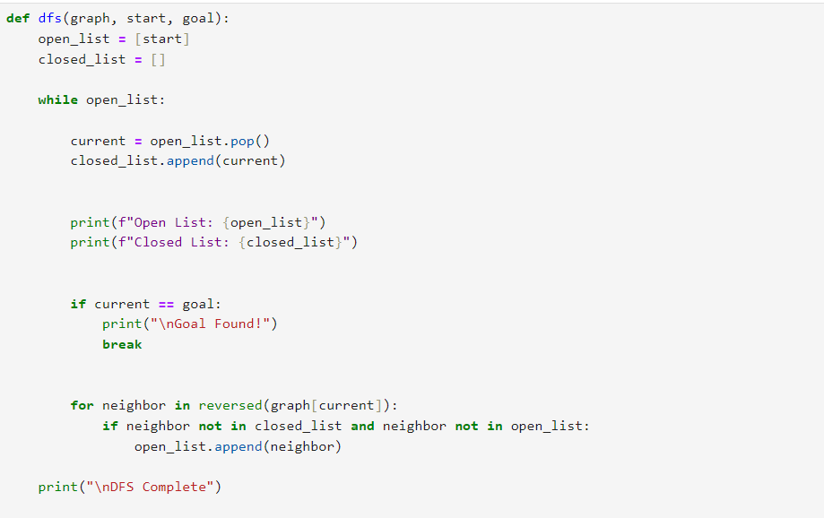

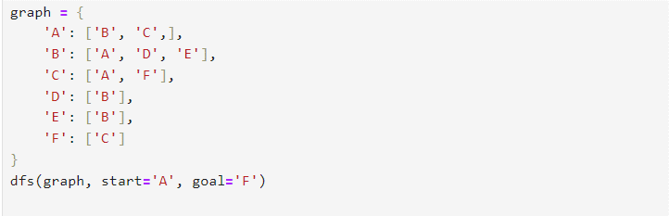

**Output:**

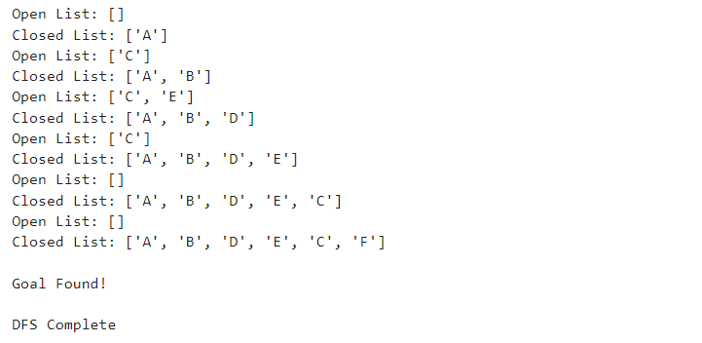

**Task03:**

Create a Class “Employee”, it’s a common base class for all the employee. Then initialize employee’s parameter like empName, empID and salary and create function like displayCount() contain total number of employee in your knowledge base and displayEmployee() contain empName, empID and their salary.

**CODE:**

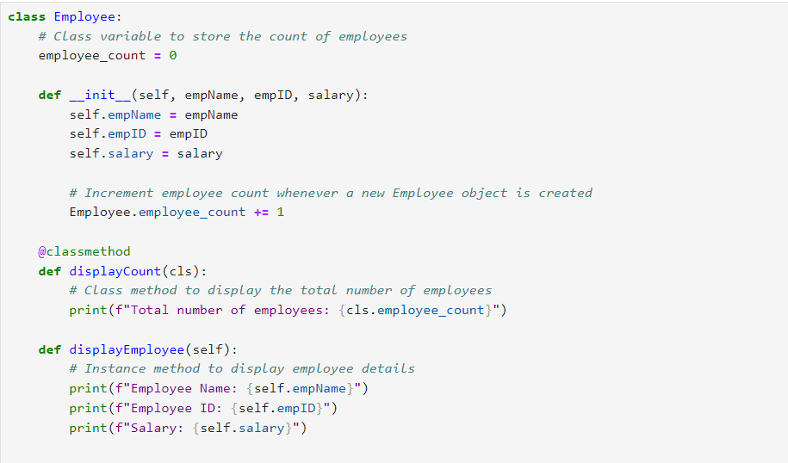

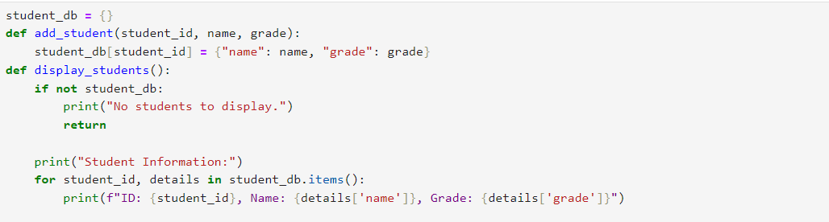

**Task04:**

Design a Python program to perform the following tasks using dictionaries:

Create an empty dictionary named student_db to store student information. Implement a function add_student that takes student ID, name, and grade as parameters, Implement a function display_students. Implement a function get_average_grade that calculates and returns the average grade of all students in the student_db. Create instances of students in the student_db, invoke the functions you implemented, and demonstrate their functionality.

**CODE:**

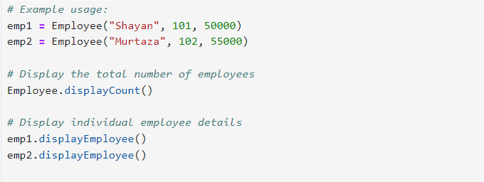

**Output:**

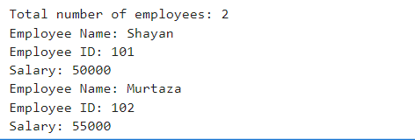

**Output:**

